CONTENTS

- Certificate 1
- Certificate of approval 2
- Declaration 3
- Acknowledgement 4
- Objective & Scope of the Project 6
- Theoretical Background 8
- Definition of Problem 21
- System Analysis & User Requirements 22
- System Planning (PERT Chart) 23
- Methodology adopted, System Implementation & Details of H/W& S/W used 25
- Detailed Life Cycle of the Project 26
- ERD, DFD 29
- Process involved, Algorithm, Flowchart, Database diagram 32
- Input and Output Screen Design(Snapshots) 39
- Methodology used for testing 56
- User/Operational Manual (security aspects, access rights, back up, controls, etc.) 58
- Future enhancement 60
- Conclusions 61
- references 63

Introduction
The objective of College Management System is to allow the administrator of any organization to edit and find out the personal details of a student and allows the student to keep up to date his profile. It’ll also facilitate keeping all the records of students, such as their id, name, mailing address, phone number, DOB etc. So, all the information about a student will be available in a few seconds. Overall, it’ll make Student Information an easier job for the administrator and the student of any organization. The main purpose of this project is to illustrate the requirements of the project College Management System and is intended to help any organization to maintain and manage personal data. It is a comprehensive project developed from the ground up to full fill the needs of colleges as they guide their students. This education edge integrated information management system connects daily operations in the college environment ranging from registration to finance, faculty, and library. This reduces data error and ensures that information is always up-to-date throughout the college. It provides a single source of data repository for streamlining your business processes and for all reporting purposes. It has a simple user interface and is intuitive. This insures that the users spend less time in learning the system and hence, increase their productivity. Efficient security features provide data privacy and hence; increase their productivity.

1. Objective & Scope

1.1 Objective
The College Management System is a simple project for keeping records of students, teachers, subjects, schedules, and all the college-related things. The project contains the user and admin sides. The admin has to manage all the management like adding students’ or teachers’ details and view their information as per the need. Admin has an important role in the management of this system. This project makes a convenient way for any educational organization to keep records of their students and teachers.
College management system is automated software that provides a more productive way of college management. This is a web oriented application allows us to access the whole information about the college, staffs, students, facilities etc. This application provides a virtual tour of Campus. Here we will get the latest information about the students and staffs. This generic application designed for assisting the students of an institute regarding information on the courses, subjects, classes, assignments, grades and timetable. It also provides support that a faculty can also check about his daily schedule, can upload assignments, and notices to the students. Here administrator will manage the accounts of the student and faculties, makes the timetable, and upload the latest information about the campus.

1.2 Scope
- College information: Through this service one can access the complete information about the college campus such as courses available, admission procedure, placements, college events, achievements etc.
- Student tracking: Any company or any organization that want to check the summary about the student of the college, so that they will be able to choose the particular students for their campus placement And for that purpose they will be given a particular link through which they can access the information required.
- Student attendance status: It gives the attendance status of students. Faculty will update the attendance periodically and can be seen by students and parents.
- Student’s performance in exams: This facility provides the performance of the student in each exam which is conducted by university or college such as midterm performance. Marks obtained by students in exams will be updated by faculties that can be access by students and parents.
- Online assignments: This service provides the facility to faculty to upload assignments and to students to submit these assignments online.
- Information about staff: It will help in maintaining complete information about college faculty members such as their department, cadre, date of joining, salary, etc. Administrator will register new faculties and remove their account when they leave the college.
- Student Admission Management: This module explains how the college handles the admission of their students. Student admission management includes the gathering of students’ basic information and requirements for admission.
- Faculty and Student Attendance Management: The college management system should have this module to check faculty and student attendance. This will record the everyday attendance and activities of everyone in the college.
- Student Information Management: In this module, the admin of the college can have and monitor the information of the students. This will also do the securing of each student’s info for tracing their transactions.
- Courses and Subjects Management: The courses and subject management module will do the assigning of subjects for every course that the college offers. This module will also bracket the schedules of each subject and the instructors that handle each subject.
- Timetables Management: The work of this module will monitor and set the timetable or range of the subjects in each semester of the academic year.
- Student Transaction Management: This module will help the admin monitor and check the content of each transaction made by their students.
- Grading System Management: The grading system management will do the job of calculating the grades of the students. Instructors or the admin will just have to encode the students’ output to the system

2. Theoretical Background
Today in colleges student details are entered manually. The student details in separate records are tedious task. Referring to all these records and updating is needed. There is a chance for more manual errors.
Problems in existing system:
- It was limited to a single system.
- It was less user-friendly.
- It have a lots of manual work (Manual system does not mean that we are working with pen and paper, it also include working on spread sheets and other simple software's)
- It requires more no of employees need to work.
- It was time consuming process.
- The present system was very less secure.
- It is unable to generate different kinds of report.

Solution to these problems:
The development of the new system contains the following activities, which try to automate the entire process keeping in view of the database integration approach.
- User friendliness is provided in the application with various controls.
- The system makes the overall project management much easier and flexible.
- It can be accessed over the Internet.
- Various classes have been used to provide file upload and mail features.
- There is no risk of data mismanagement at any level while the project development is under process.
- It provides high level of security using different protocols like https etc.

3. Problem Definition

The problem is to provide the complete information about the college campus. In which the college staff members, students and parents can access the information and will be familiar with college campus. It will provide interactive environment for the staff, students and parents by getting knowledge of student attendance, remarks, exams performances, grades, timetables, notices etc.

Basic Concept and Definitions
Product Perspective
The CIMS is a system that can help to maintaining student and staff information easily and it will maintain the student records, library, schedules, important events and many other important information related to college management.
The website is aimed towards recording a considerable number of student records and need assistance for managing their data. Website is user-friendly, quick to learn and reliable.
CIMS is a stand-alone product and doesn’t depend upon the availability of any other websites. The system will have an administrator who has full-fledged rights with regards to performing all actions related to control and management of the website and all relevant data.
Functions
There are three different users who will be using this product:
• Admin who can view and edit the details of any students.
• Faculty who can view their schedules, library, their profile information as well as they can edit their information
• Students who can view their details, library, course material, as well as they can edit their information.
The features that are available to administrator are:
- An administrator can login into the system and perform any of the available operations
  - can delete user
  - can accept/decline user registration request
  - can edit user information records into database
  - can access all details
The features that are available to faculty are:
- A faculty can login into the system and perform any of the available operations
  - can view his/her information
  - can edit their details
  - can access library records
  - can view their schedule
The features that are available to faculty are:
- A student can login into the system and perform any of the available operations
  - can view his/her information
  - can edit their details
  - can access library records
  - can view their course detail and related material
Characteristics
- User should be aware of internet.
- User should have a valid login ID and password.
- Admin, faculty and student can access
- Guest user send their registration request
Constraints
- Every user must be comfortable using computer
- All operations are in English, so user must have basic knowledge of English.

4. System analysis & planning v/s user requirement
4.1 User requirements:
The following requirements are raised during the analysis of the needs of the users:
- A Person Should be able to login to the system through the first page of the Application.
- The Administrator can create users as per user requirement.
- Admin can upload the data for a particular Student. On successful completion of upload, user (Student/Parent/Faculty) can view reports.
- A general user will have access to see the status of particular Student id number.
- Student (user) can use all the facilities, same as which are provided to him in the college.
- Student can see attendance, notices, grades, report and other facilities in updated manner.
- There will be a separate page for every student as his account in which he can get notices, attendance, grades, assignments etc.
- Parent can just view the record of student with the username and password provided.
- Faculty can give the attendances and notices for the students.
- The administrator verifies all these reports and generates them for users to view them.

After analyzing the requirements of the task to be performed, the next step is to analyze the problem and understand its context. The first activity in the phase is studying the existing system and other is to understand the requirements and domain of the new system. Both the activities are equally important, but the first activity serves as a basis of giving the functional specifications and then successful design of the proposed system. Understanding the properties and requirements of a new system is more difficult and requires creative thinking and understanding of existing running system is also difficult, improper understanding of present system can lead diversion from solution.
4.2 Analysis Model
This document play a vital role in the development of life cycle (SDLC) as it describes the complete requirement of the system. It means for use by developers and will be the basic during testing phase. Any changes made to the requirements in the future will have to go through formal change approval process.
SPIRAL MODEL was defined by Barry Boehm in his 1988 article, “A spiral Model of Software Development and Enhancement. This model was not the first model to discuss iterative development, but it was the first model to explain why the iteration models.
As originally envisioned, the iterations were typically 6 months to 2 years long. Each phase starts with a design goal and ends with a client reviewing the progress thus far. Analysis and engineering efforts are applied at each phase of the project, with an eye toward the end goal of the project.
The steps for Spiral Model can be generalized as follows:
- The new system requirements are defined in as much details as possible. This usually involves interviewing a number of users representing all the external or internal users and other aspects of the existing system.
- A preliminary design is created for the new system.
- A first prototype of the new system is constructed from the preliminary design. This is usually a scaled-down system, and represents an approximation of the characteristics of the final product.
- A second prototype is evolved by a fourfold procedure:
- Evaluating the first prototype in terms of its strengths, weakness, and risks.
- Defining the requirements of the second prototype.
- Planning and designing the second prototype.
- Constructing and testing the second prototype.
- At the customer option, the entire project can be aborted if the risk is deemed too great. Risk factors might involved development cost overruns, operating-cost miscalculation, or any other factor that could, in the customer’s judgment, result in a less-than-satisfactory final product.
- The existing prototype is evaluated in the same manner as was the previous prototype, and if necessary, another prototype is developed from it according to the fourfold procedure outlined above.
- The preceding steps are iterated until the customer is satisfied that the refined prototype represents the final product desired.
- The final system is constructed, based on the refined prototype.
- The final system is thoroughly evaluated and tested. Routine maintenance is carried on a continuing basis to prevent large scale failures and to minimize down time.
The following diagram shows how a spiral model acts like:

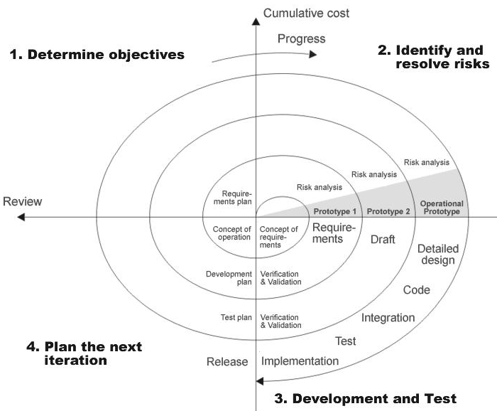

4.3 Study of the System:
4.3.1 Graphical user interface
In the flexibility of the uses the interface has been developed a graphics concept in mind, associated through a browses interface. The GUI’S at the top level have been categorized as
- Administrative user interface
- The operational or generic user interface
The administrative user interface concentrates on the consistent information that is practically, part of the organizational activities and which needs proper authentication for the data collection. The interfaces help the administrations with all the transactional states like Data insertion, Data deletion and Date updation along with the extensive data search capabilities.
The operational or generic user interface helps the users upon the system in transactions through the existing data and required services. The operational user interface also helps the ordinary users in managing their own information helps the ordinary users in managing their own information in a customized manner as per the assisted flexibilities.

4.4 Number of Modules
The system after careful analysis has been identified to be presented with the following modules:
The modules involved are:
- College information: Through this service one can access the complete information about the college campus such as courses available, admission procedure, placements, college events, achievements etc.
- Student tracking: Any company or any organization that want to check the summary about the student of the college, so that they will be able to choose the particular students for their campus placement And for that purpose they will be given a particular link through which they can access the information required.

- Student attendance status: It gives the attendance status of students. Faculty will update the attendance periodically and can be seen by students and parents.
- Student’s performance in exams: This facility provides the performance of the student in each exam which is conducted by university or college such as midterm performance. Marks obtained by students in exams will be updated by faculties that can be access by students and parents.
- Exam Notification: This facility notifies students and parents about examination schedule.
- Events: it will give information about different events that will be conducted by college time to time. Information about these events will be updated by administrator.
- Online assignments: This service provides the facility to faculty to upload assignments and to students to submit these assignments online.
- Information about staff: It will help in maintaining complete information about college faculty members such as their department, cadre, date of joining, salary, etc. Administrator will register new faculties and remove their account when they leave the college.

5. SYSTEM PLANNING (PERT CHART)
Perform and evaluate feasibility studies like cost-benefit analysis, technical feasibility, time feasibility and operational feasibility for the project. Project Scheduling should be made using PERT charts.
Feasibility study is carried out t decide whether the proposed system is feasible for the company. The feasibility study is to serve as a decision document it must answer three key questions:
- Is there a new and better way to do the job that will benefit the user?
- What are the cost and the savings of the alternative(s)?
- What is recommended?

Technical feasibility:
Technical feasibility centers on the existing computer system i.e. Hardware, Software etc. Bank requires SQL database management that are all easily available with extensive development support through manuals and blogs.

Economical feasibility:
Economical Feasibility is the most frequently used method for evaluating the effectiveness of a candidate system. More commonly known as Cost/ Benefit analysis, the procedure is to determine the benefits and savings that are expected from the candidate system and compare them with costs. If the benefits outweigh costs, then the decision is made to design and implement the system.

6. Methodology Adopted, System Implementation & Details of Hardware & Software Used

6.1 Methodology adopted and System implementation:
- Apache tomcat is used as a web server to host the application.
- All the environment variables are set.
- The application is pasted in the webapps folder.
- Web server is started now.
- Application is run using the web browser by typing http://localhost/cis
- Web.xml file is used to control the flow and user actions.

6.2 Details of hardware & software used:
Hardware Specification (Minimum):

Disc Space: 40 GB
PC Used: IBM Compatible
Processor: Pentium 3
Memory: 512 MB RAM
File System: 32 Bit

Software Specification:

Operating System (Server Side): Windows XP.
Operating System (Client Side): Windows XP.
Client End Language: HTML
Local Validation: PHP
Server Side Language: PHP
Database: My Sql 2000
Web Server: XAMPP server
Web Browser: Internet Explorer 8/ Mozilla Firefox

- DETAILED LIFE CYCLE OF PROJECT
We have used Waterfall Model as Software Engineering life Cycle Process. It is the simplest; oldest and most widely used process model for software development .This model acquires its name from the fact that classic software life cycle is represented as a sequence of descending steps.
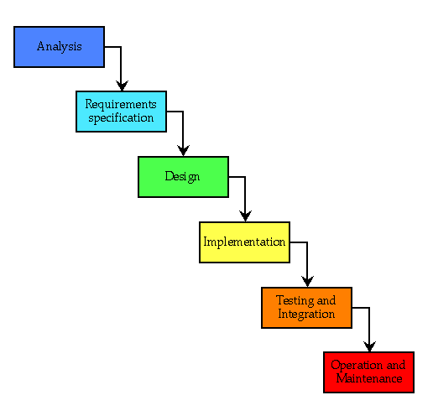
7.1 Requirement Analysis:
This process is also known as feasibility study. In this phase, the development team studied the site requirement. They investigate the need for possible dynamic representation of the site and increase security features. By the end of feasibility study, the team furnishes a document that holds the different specific recommendations for the candidate system. It also includes personnel assignments, costs, project schedules, target dates etc. the requirement gathering process is intensified and focused specially on software. The essential purpose of this phase is to find the need and to define the problem that needs to be solved. During this phase following facts were gathered.
- Determined the user need
- Identified the facts
- Establish the goals and objective for the proposed system
- Feasibility for the new system

7.2 System Analysis and Design:
In this phase the software’s overall structure and its nuances are defined. In terms of client server technology the no of tiers needed for the package architecture, database design, data structure design etc are defined in this phase. Analysis and Design are very crucial in entire development cycle. Any glitch in this phase could be expensive to solve in the later stage of software development. Hence following is the essential approach taken during website designing:
- DFD
- Database Designing
- Form Designing
- Pseudo code for methods

7.3 Testing:
Once the code is generated, the website testing begins. Different testing methodologies are done to unravel the bugs that were committed during the previous phases. Different testing methodologies are used:
- Acceptance testing
- White Box Testing
- Black Box Testing

- Data Flow Diagram
Use-case: Display user details
Goal: View user details
Brief: This use case is when the administrator wants to view the personal details of users that are already existing in the database.
Perquisites:
• The admin must be logged onto the website for this se case to begin.
• The details of the users must pre-exist in the database.
• The student id must be entered correctly.
Basic Flow:
• The administrator logs onto the system.
• The administrator searches the user by
      - Email
      - Name
The system views the user detail.
Alternative Flow: User not found
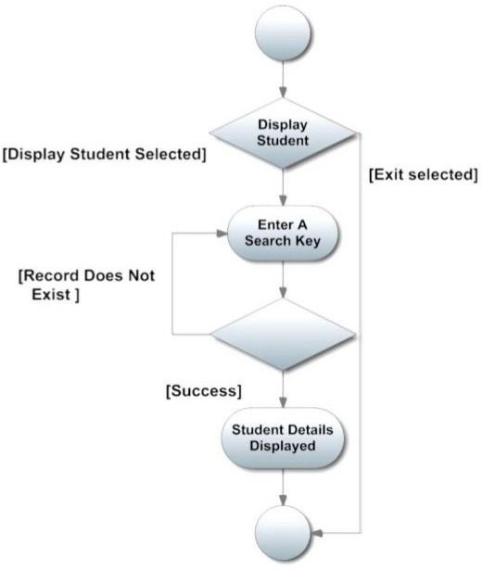
If in the display, a user with the specific Id does not exist, system generates an error message. The administrator can then enter a different Id or cancel the operation, when error occurred.

Use-case: Edit user details
Goal: Edit the details of user

Brief: This use case is when the administrator wants to edit the personal details of users that are already existing in the database.
Perquisites:
- The admin must be logged onto the website for this se case to begin.
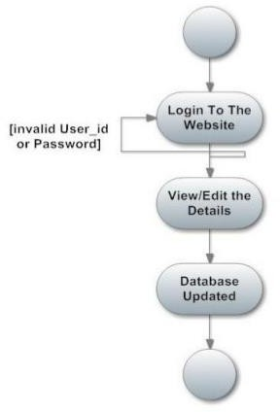
- The details of the users must pre-exist in the database.
Figure 5: Use case - edit user details
Basic Flow:
- The administrator logs onto the system.
- The administrator edits the user details
  - Email
  - First Name/Last name
  - DOB
  - Qualification
  - City
  - Contact No
  - Address
The website updates the database according to the edited details.
Alternative Flow: No alternative flow for this use case.

User: Student

Use-case: User registration

Goal: Registration of user

Brief: This use case is when the user send registration request himself/herself in the database online.

Perquisites:

- The student must access the website for this use case to start.
- The input must be entered correctly.

Basic Flow:

The student enters the website.
The student fills his/her details from the following:
- Email
- Password
- First name/Last name
- Gender
- DOB
- Contact No
- Qualification
- Address
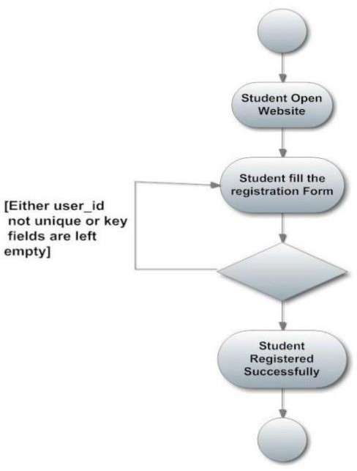
Alternative Flow: Validates all the user
Functional Requirements

- The Administrator will be given more powers (accept/decline/update) than other users.
- It ensures that the information entered is of correct format. For example, name field cannot contain numbers. In case if incorrect information is given, the user will be asked to fill the information again.
- The applications can be accessed any time.

Non-Functional Requirements

- The database may get crashed at any certain time due to virus of operating system failure. Therefore, it is required to take the database backup.
- The proposed system we are going to develop will be used as the major performance system for providing help to the organization in managing the whole database of the student studying in the organization.

Design

Objectives

The overall design objective is to provide an efficient, modular design that will reduce the system’s complexity, facilitate change and result in an easy implementation. This will be accomplished by designing strongly cohesion system with minimal coupling. In addition, this document will provide interface design models that are consistent user friendly and will provide straight forward transition through the various system functions.
The purpose of the design phase is to develop a clear understanding of what the developer wants people to gain from his/her project. As you the developer work on the project, the test for every design decision should be "Does this feature fulfil the ultimate purpose of the project?" The Design Document will verify that the current design meets all the explicit requirements contained in the system model as well as the implicit requirements desired.

System Architecture

The CIMS is systems which contain major part which include: user detail, user records and other options. The user selects one of the available options as an input to the system. According to the input by the user the system acts, and the rest of the functions are performed accordingly. The administrator can operate on any user details. But the normal users can only access their details of all the functionalities.

Data Design

Entity-Relationship Diagram

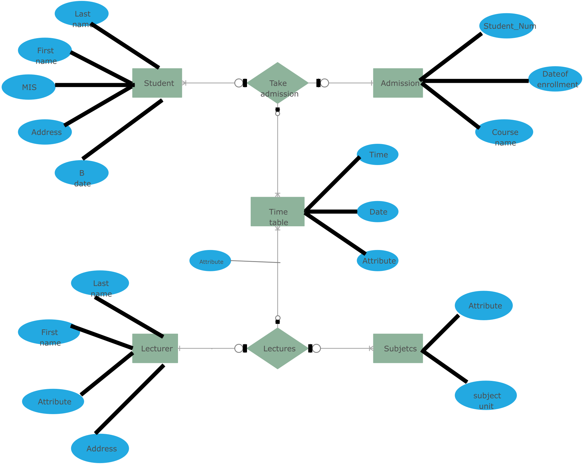

Data Flow Diagram:-
8.2.1 Context 0th Level Diagram:
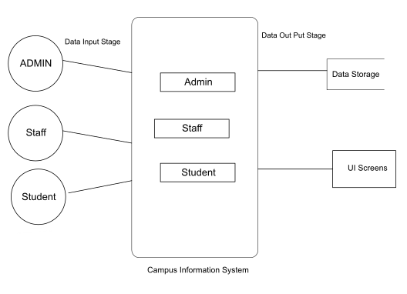
8.2.2 Login DFD Diagram:
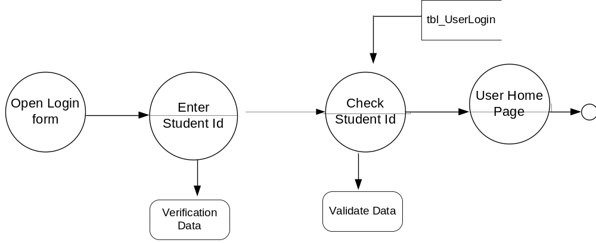

8.2.3 Admin Details Data Flow:

1st level DFD:

Admin
Login
Enter details
Update

Students info

2nd Level DFD

Admin
Id
Password
Login
Login

Admin
Enter details
Student table

Admin
Modify
Student Student table

Faculty info.

Notification

8.2.4 Student Details Data Flow
1st level DFD

Student

Login
Enter details
Update

Student’s info

2nd level DFD

Id
Student
Login
Login

View marks
Attendance
Notices
Grades
Student

Password

Student table

Use Case diagram
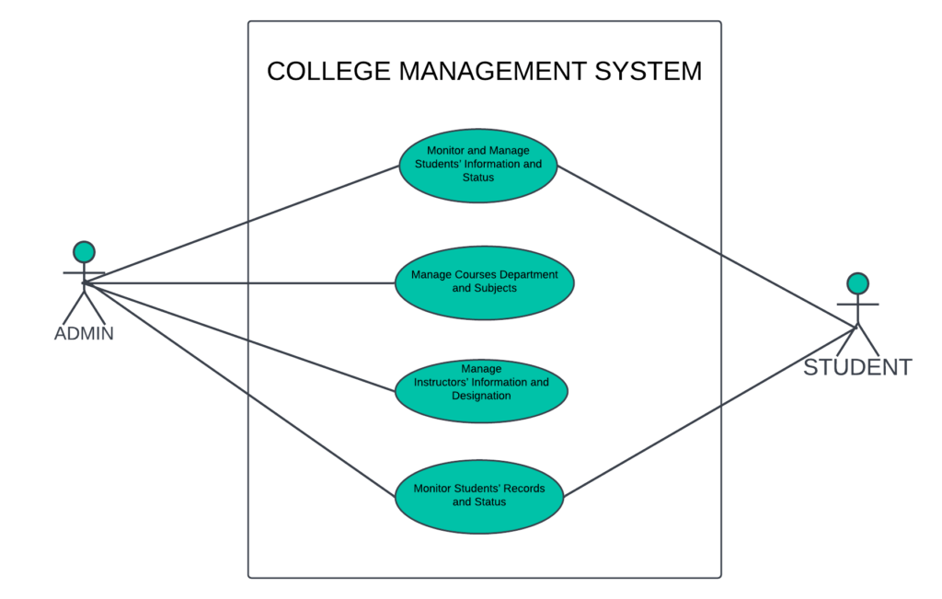
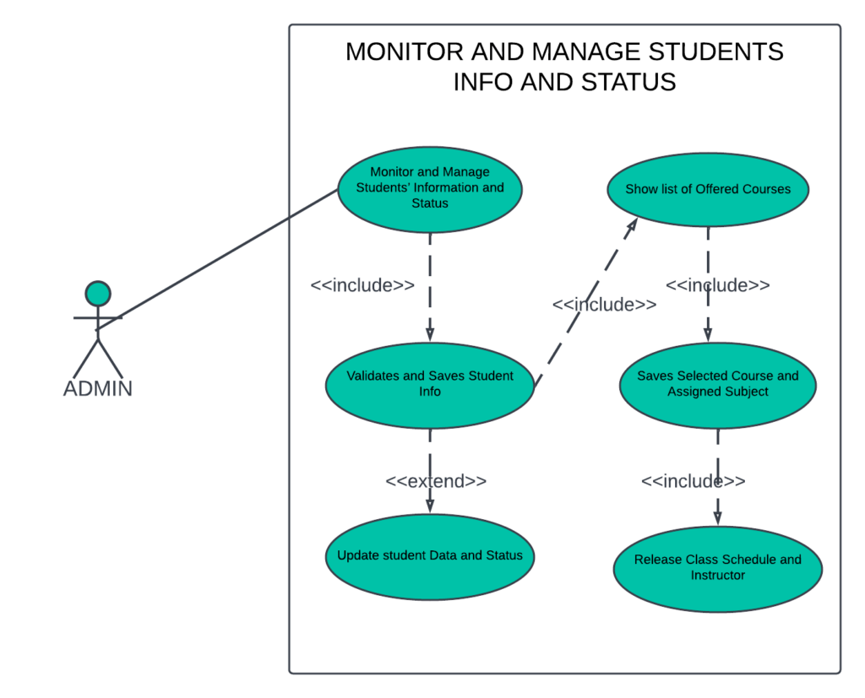
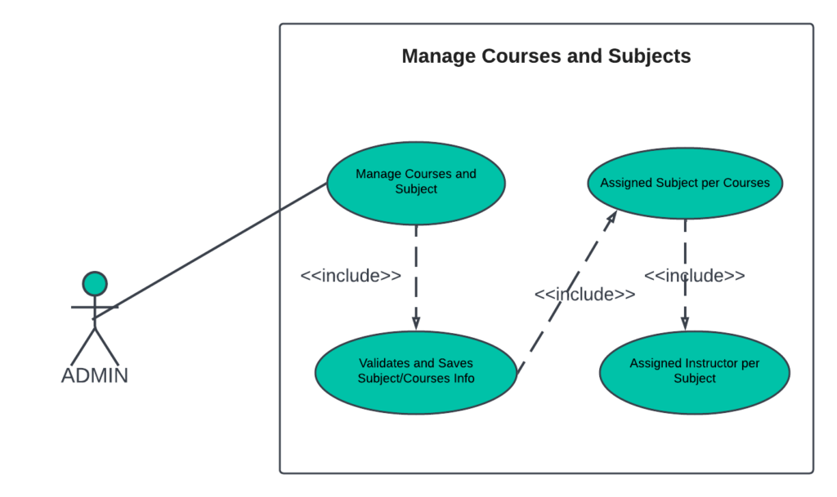

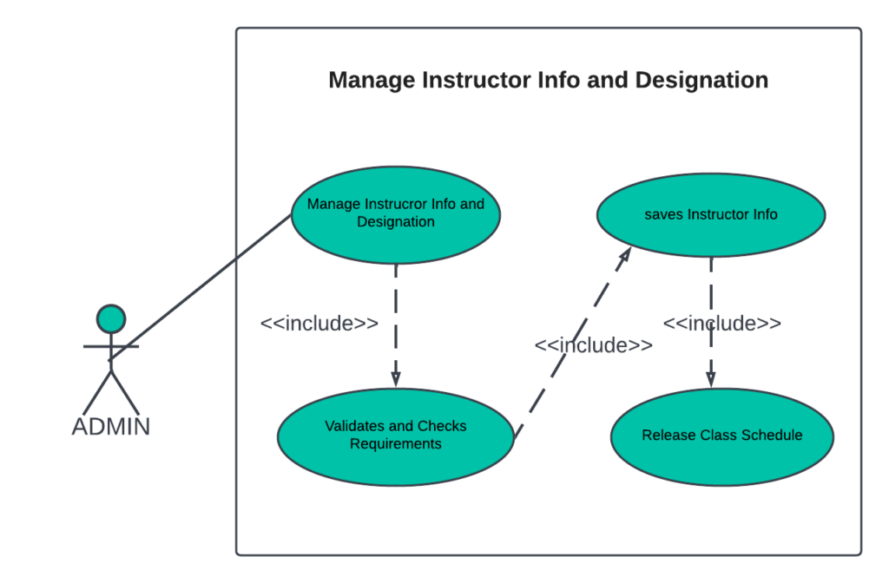
- Technological Description
The technology selected for implementing College Management System is JSP/MySQL. Glassfish is used as the HTTP server. The development was done in a ‘windows operating system’ using Net Beans IDE.

HTML

HTML (Hypertext Mark-up Language) is the most basic building block of the Web. It describes and defines the content of a webpage. Other technologies besides HTML are generally used to describe a webpage's appearance.
"Hypertext" refers to links that connect webpages to one another, either within a single website or between websites. Links are a fundamental aspect of the Web. By uploading content to the Internet and linking it to pages created by other people, you become an active participant in the World Wide Web.

CSS

Cascading Style Sheets (CSS) are a stylesheet language used to describe the presentation of a document written in HTML or XML (including XML dialects like SVG or XHTML). CSS describes how elements should be rendered on screen, on paper, in speech, or on other media. CSS is one of the core languages of the open web and has a standardized W3C. Developed in levels, CSS1 is now obsolete, CSS2.1 is a recommendation, and CSS3, now split into smaller modules, is progressing on the standardization track.

JAVASCRIPT

JavaScript is a lightweight, interpreted programming language. It is designed for creating network-centric applications. It is complimentary to and integrated with Java. JavaScript is very easy to implement because it is integrated with HTML. It is open and cross-platform.

MySQL

MySQL is a relational database management system (RDBMS) that runs as a server providing multi-user access to several databases. MySQL is a popular choice of database for use in web applications and is an open source product. The process of setting up a MySQL database varies from host to host; however, we will end up with a database name, a user name and a password. Before using our database, we must create a table. A table is a section of the database for storing related information. In a table we will set up the different fields which will be used in that table. Creating a table in MySQL is simple, we just type the name, select the number of fields and click the ‘go’ button. we will then be taken to a setup screen where you must create the fields for the database. Another way of creating databases and tables in MySQL is by executing simple SQL statements. We have used this method to create our database and tables.

PHP

PHP (recursive acronym for PHP: Hypertext Pre-processor) is a widely-used open source general-purpose scripting language that is especially suited for web development and can be embedded into HTML.
    - PHP is an acronym for "PHP: Hypertext Pre-processor"
    - PHP is a widely-used, open source scripting language
    - PHP scripts are executed on the server
    - PHP is free to download and use

Why PHP:

    - PHP runs on various platforms (Windows, Linux, Unix, Mac OS X, etc.)
    - PHP is compatible with almost all servers used today (Apache, IIS, etc.)
    - PHP supports a wide range of databases
    - PHP is free. Download it from the official PHP resource: www.php.net
    - PHP is easy to learn and runs efficiently on the server side

What Can PHP Do:

    - PHP can generate dynamic page content
    - PHP can create, open, read, write, delete, and close files on the server
    - PHP can collect form data
    - PHP can send and receive cookies
    - PHP can add, delete, modify data in your database
    - PHP can be used to control user-access

With PHP you are not limited to output HTML. You can output images, PDF files, and even Flash movies. You can also output any text, such as XHTML and XML.

An introductory example

<!DOCTYPE HTML>
<html>
<head>
<title>Example</title>
</head>
<body>

<?php
echo "Hi, I'm a PHP script!";
?>

</body>
</html>

- Input and Output Screen Design (Snapshots)

SCREENSHOTS

Home Screen :
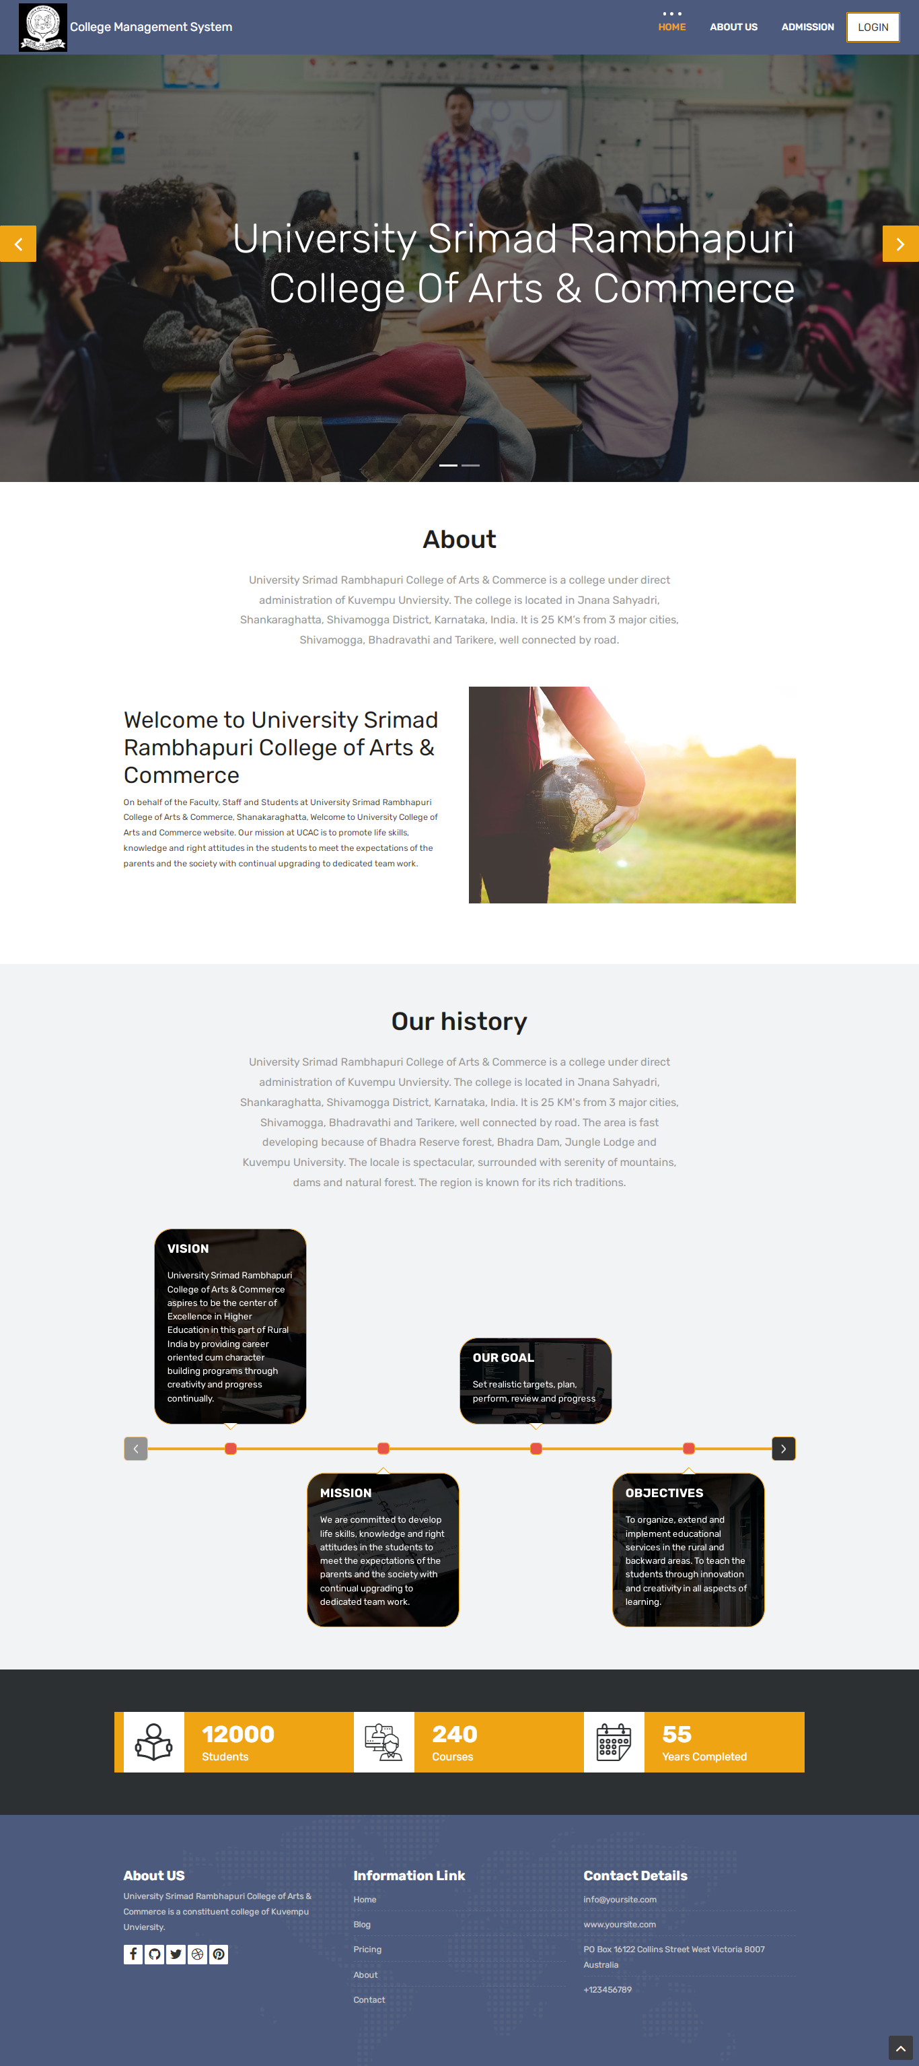
This above screen shows user home page where user can get the information about the college . When user click on home page, the login page will displayed. 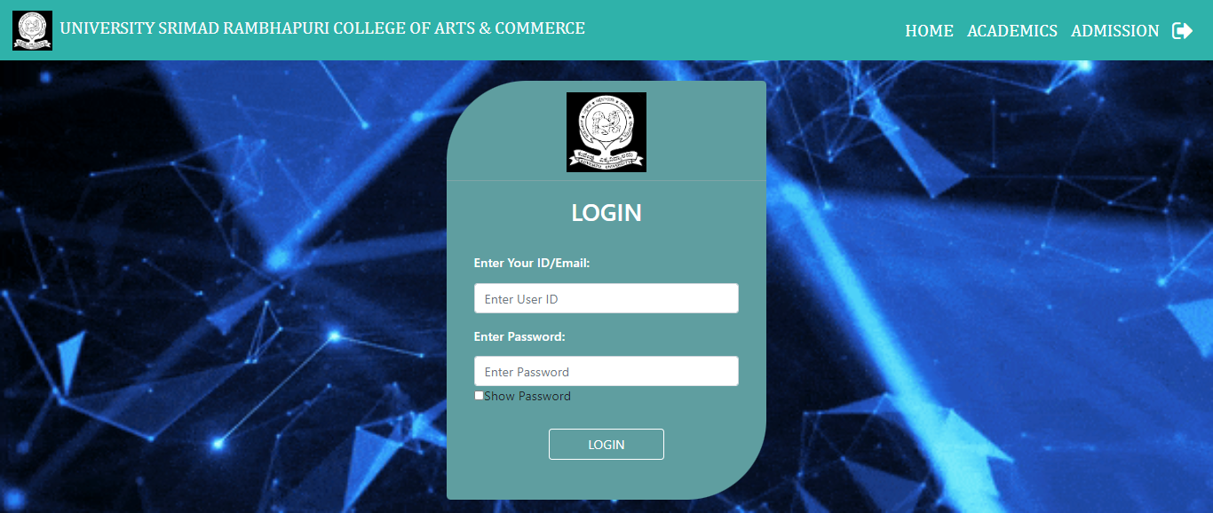

10. Methodology used for testing
The completion of a system will be achieved only after it has been thoroughly tested. Though this gives a feel the project is completed, there cannot be any project without going through this stage. Hence in this stage it is decided whether the project can undergo the real time environment execution without any break downs, therefore a package can be rejected even at this stage.
10.1 Testing methods
Software testing methods are traditionally divided into black box testing and white box testing. These two approaches are used to describe the point of view that a test engineer takes when designing test cases.
- Black box testing - Black box testing treats the software as a "black box," without any knowledge of internal implementation. Black box testing methods include: equivalence partitioning, boundary value analysis, all-pairs testing, fuzz testing, model-based testing, traceability matrix, exploratory testing and specification-based testing.
- White box testing - White box testing, by contrast to black box testing, is when the tester has access to the internal data structures and algorithms (and the code that implement these).White box testing methods can also be used to evaluate the completeness of a test suite that was created with black box testing methods. This allows the software team to examine parts of a system that are rarely tested and ensures that the most important function points have been tested.
- Grey Box Testing - Grey box testing involves having access to internal data structures and algorithms for purposes of designing the test cases, but testing at the user, or black-box level. Manipulating input data and formatting output do not qualify as "grey box," because the input and output are clearly outside of the "black-box" that we are calling the system under test. This distinction is particularly important when conducting integration testing between two modules of code written by two different developers, where only the interfaces are exposed for test. Grey box testing may also include reverse engineering to determine, for instance, boundary values or error messages.

Acceptance testing - Acceptance testing can mean one of two things:
- A smoke test is used as an acceptance test prior to introducing a build to the main testing process.
- Acceptance testing performed by the customer is known as user acceptance testing (UAT).

Regression Testing - Regression testing is any type of software testing that seeks to uncover software regressions. Such regression occurs whenever software functionality that was previously working correctly stops working as intended. Typically regressions occur as an unintended consequence of program changes. Common methods of regression testing include re-running previously run tests and checking whether previously fixed faults have re-emerged.

Non Functional Software Testing - Special methods exist to test non-functional aspects of software.
- Performance testing checks to see if the software can handle large quantities of data or users. This is generally referred to as software scalability. This activity of Non Functional Software Testing is often times referred to as Load Testing.
- Stability testing checks to see if the software can continuously function well in or above an acceptable period. This activity of Non Functional Software Testing is often times referred to as indurations test.
- Usability testing is needed to check if the user interface is easy to use and understand.
- Security testing is essential for software which processes confidential data and to prevent system intrusion by hackers.
- Internationalization and localization is needed to test these aspects of software, for which a pseudo localization method can be used.
- Scope of the Project:
- The College Management System (CIMS) can be enhanced to include some other functionality like marks, attendance management.
- Talent management of students based on their performance evaluation can be added. Social networking can also be added wherein students can interact with each other.
- Online class functionality can be added.
- Can evolve as an online institution.
- Functionality of chat and messages can be added.
- Online exam functionality can be added.
- Bibliography
- The Complete reference on PHP
- www.google.com.
- www.wikipedia.com
- www.tutorialspoint.com
- www.getbootstrap.com
- www.studytonight.com
- www.stackoverflow.com
- www.roseindia.net

- Conclusion
- The application provides appropriate information to users according to the chosen service.
- The project is designed keeping in view the day to day problems faced by a college.
- Deployment of our application will certainly help the college to reduce unnecessary wastage of time in personally going to each department for some information
- Awareness and right information about any college is essential for both the development of student as well as faculty.

Sample Code:

1. Database Connection

<?php
$con=mysqli_connect("localhost","root","","college_mng");
if(!$con)
{
echo "Connection is not Successfully";
}
?>

2. Login Page

<!-- PHP Starts Here -->
<?php
session_start();
require_once "../connection/connection.php";
$message="Email Or Password Does Not Match";
if(isset($_POST["btnlogin"]))
{
$username=$_POST["email"];
$password=$_POST["password"];

$query="select * from login where user_id='$username' and Password='$password' ";
$result=mysqli_query($con,$query);
if (mysqli_num_rows($result)>0) {
while ($row=mysqli_fetch_array($result)) {
if ($row["Role"]=="Admin")
{
$_SESSION['LoginAdmin']=$row["user_id"];
header('Location: ../admin/admin-index.php');
}
else if ($row["Role"]=="Teacher" and $row["account"]=="Activate")
{
$_SESSION['LoginTeacher']=$row["user_id"];
header('Location: ../teacher/teacher-index.php');
}
else if ($row["Role"]=="Student" and $row["account"]=="Activate")
{
$_SESSION['LoginStudent']=$row['user_id'];
header('Location: ../student/student-index.php');
}
}
}
else
{

echo "<script>alert('Invalid username/Password');
location.href='login.php';
</script>";

}
}
?>

<!doctype html>
<html lang="en">
<head>
<title>Login - ICBS</title>
</head>
<body class="login-background">
<?php include('../common/common-header.php') ?>
<div class="login-div mt-3 rounded">
<div class="logo-div text-center">
<img src="../Images/download.png" alt="" class="align-items-center" width="100" height="100">
</div>
<div class="login-padding">
<h2 class="text-center text-white">LOGIN</h2>
<form class="p-1" action="login.php" method="POST">
<div class="form-group">
<label><h6>Enter Your ID/Email:</h6></label>
<input type="text" name="email" placeholder="Enter User ID" class="form-control" required>
</div>
<div class="form-group">
<label><h6>Enter Password:</h6></label>
<input type="Password" name="password" placeholder="Enter Password" id="myInput" class="form-control border-bottom" required>
<input type="checkbox" onClick="myFunction()">Show Password

<!-- <?php echo $message; ?> -->
</div>
<div class="form-group text-center mb-3 mt-4">
<input type="submit" name="btnlogin" value="LOGIN" class="btn btn-white pl-5 pr-5 ">
</div>
</form>
</div>
</div>
</body>

<script>
function myFunction() {
var x = document.getElementById("myInput");
if (x.type === "password") {
x.type = "text";
} else {
x.type = "password";
}
}
</script>
</html>

SCREENSHOTS

